DBMS ASSIGNMENT-3

ENTITY RELATIONSHIP DIAGRAM

PARAGRAPH:



The Nasure shop has a wide range of organic, agricultural products, tools required for agriculture, organic fertilizers and pesticides. All types of products are available and customers can buy the products in online mode. Delivery is optional, as people at nearby locations do not require this option. As soon as, a customer places their order, they will get the details of delivery and order summary. Delivery details will have customer id, delivery date, items to be delivered and pin code. The order summary contains the products ordered and the important fields are customer id, order id, date of purchase and price. Products are taken for delivery and will contain the details of id, name and category. The fields of customer are id, name, address and phone number.

ER DIAGRAM:

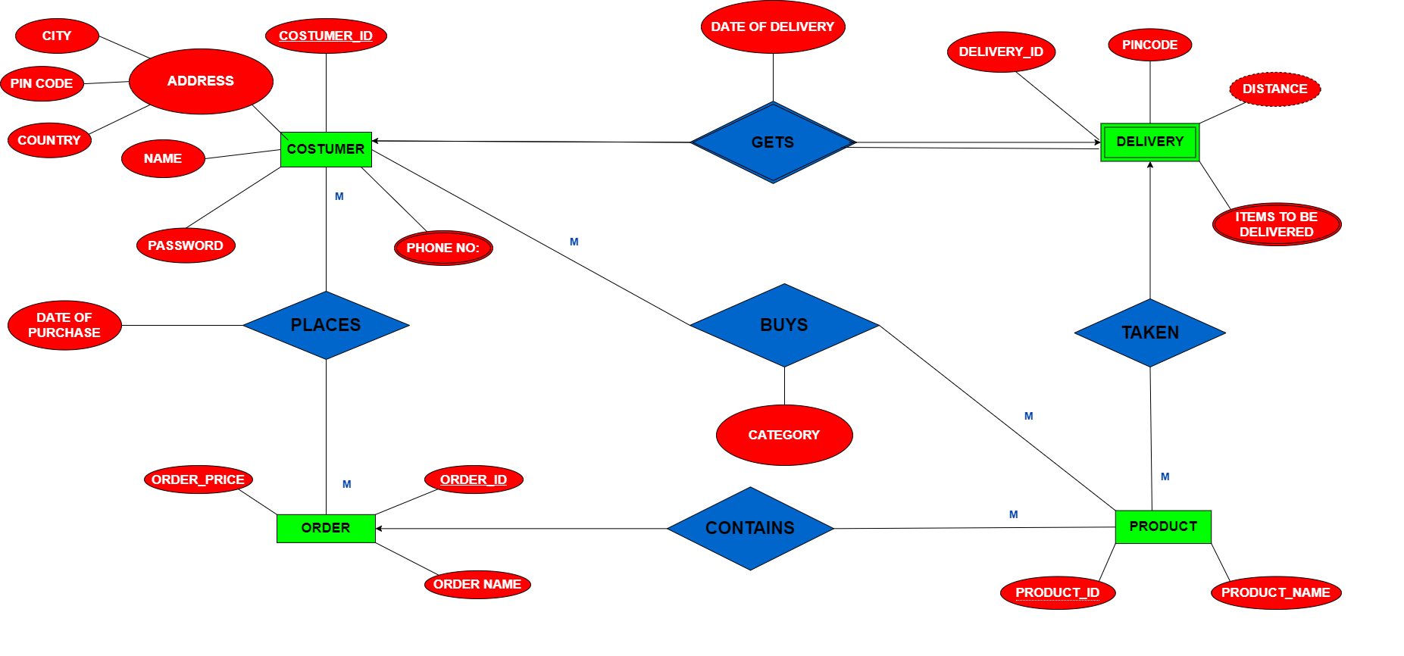

ER MODEL TO RELATIONAL SCHEMA:

* Customer (customer_id,name,password,city,pincode,country);
* Customerphone (customer_id,phone no);
* Order (order_id,order_name,order_price,customer_id,product_id);
* Product (product_id,product_name);
* Delivery (delivery_id, distance,pincode,customer_id,product_id);
* Deliveryitems (delivery_id,items to be delivered);
* Places (customer_id,order_id,date of purchase);
* Buys (customer_id,product_id,category);

GROUP-3:

AASHIKA B.S.-CB.SC.I5DAS19003

NAYANA.S.G-CB.SC.I5DAS19035

SMRITHI.N-CB.SC.I5DAS19029